Dragonball How to play
https://www.dragonball.uk.com/how-to-play/#:~:text=Winning%20the%20Game-,The%20game%20ends%20when%20all%20seven%20Dragonballs%20are%20in%20one,the%20centre%20of%20the%20pitch.

Game Play & Rules
• Divide the players into two teams with an equal number of players.
• Give each player a team-coloured Dragonball Bib and a Dragonball Tail-Tag to wear.
• Choose a goalkeeper per team. This player must stay in the goal during the game.
• Everyone on each team must start the game by standing still at their own goal line (see Dragonball Starting Positions).
• Place the seven Dragonballs in a circle in the centre of the pitch.
• To start the game, the referee shouts “3, 2, 1, Dragonball” and blows a whistle.
• Everyone can now move to collect a ball (or more than one ball) from the centre of the pitch and pass the balls between their team to score a goal.
• The first pass must be backwards towards the player’s own goal.
• As Dragonball is a non-contact sport, if the Dragon Tail of a player holding a Dragonball is removed, that player must immediately place the Dragonball at their feet and remain “out of play” until a team member reattaches their Dragon Tail, then they can continue to play.
• When a goal is scored, leave the Dragonball in the goal. It is now “out of play” until the end of the game.
• The game ends when all seven Dragonballs are in one or other goal.
• Blow a whistle to end the game.
• The winner is the team with the most balls in the opposition goal.
• Repeat with the same teams or change teams/players if appropriate.

Scoring
A goal is scored when one of the seven Dragonballs is thrown or kicked into the opponent’s goal. The Dragonball must stay in the goal until all seven Dragonballs are in one goal or the other.

Winning the Game
The game ends when all seven Dragonballs are in one goal or the other.
There is always a winner of the game, either 7-0, 6-1, 5-2, 3-4.
A whistle is blown when all seven Dragonballs have been scored in a goal. The game is then reset with the seven Dragonballs returned to the centre of the pitch.
Dragonball can last for as long or as short a timeframe as required. For example, an hour of Dragonball might result in several games being played, or one or two longer, tactical games.

Dragonball Starting Positions
• The teams start at opposite ends of the Dragonball pitch, behind the line of the goal.
• Each team has a nominated goalkeeper.
• The 7 Dragonballs start in a ring in the centre.
• Players cannot move until the referee starts the game by calling “3, 2, 1, Dragonball.
• When a goal is scored, the Dragonball stays in the goal until the end of the game.
• At the end of the game, the Dragonballs are returned to the centre ring.
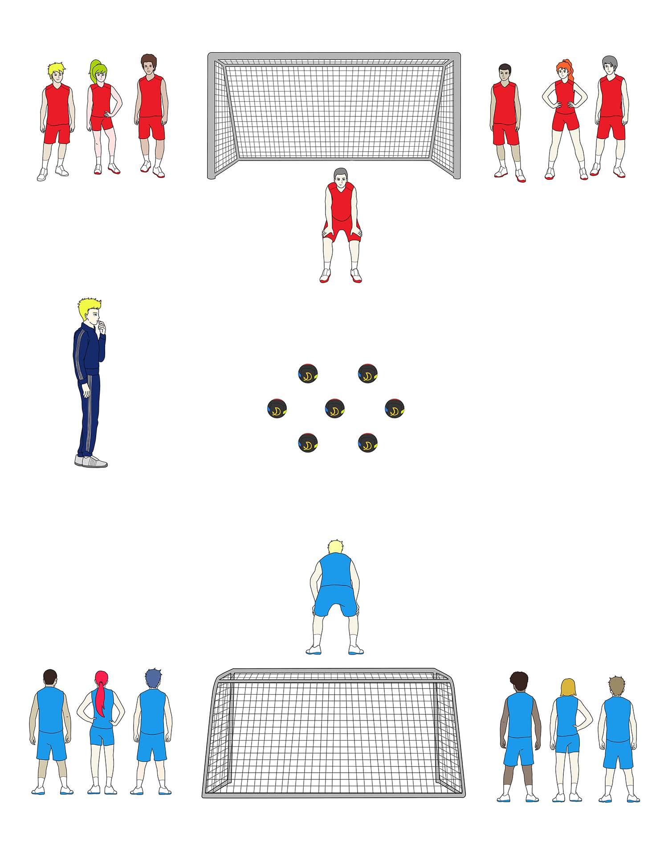

Players & Teams
Dragonball is suitable for any number of players of all ages and abilities. The players are divided into two teams of equal numbers and where possible, equal ability.

Team Size
The team size can be reduced by age, for example, limiting the team size to a maximum of 7 players per team (including the goalkeeper) for younger players.
There is no overall maximum number of players because Dragonball is designed to include everyone who wants to play. In large groups the players can be divided into more than two teams and Dragonball can be played, for example: Team A v. Team B, Team B v. Team C, Team A v. Team C etc.

Extra Player
If there is an odd number of players, one team takes the extra player so no one is left out.

Goalkeeper
One player from each team is nominated to be the goalkeeper for their team and they remain in the goal area for the duration of the game. All other players can move around the pitch whilst the game is in play.

Dragon Tails
Each player wears a “Dragon Tail” or tag on a waistband. If Player A is holding a Dragonball and Player B removes their tag, then:
Player A must immediately put the Dragonball on the ground by their feet.
Player B must immediately put the tag on the ground by their feet.
Player B can then pick up the Dragonball and rejoin the game.
Player A must stand still and wait for a member of their team to re-attach the tag before they can rejoin the game.
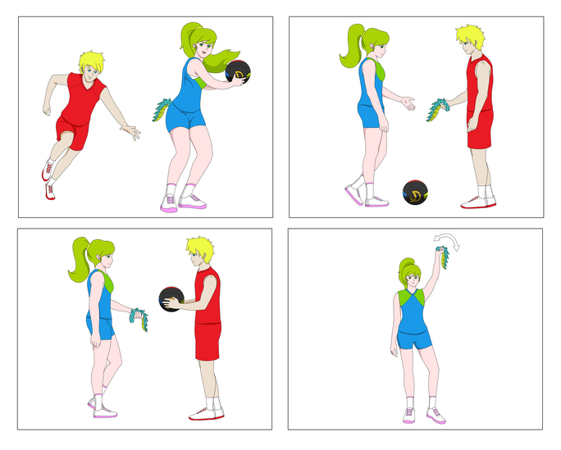

Substitutions
As everyone is included in the game, there should be no need for substitutions, however if you have chosen to keep some players on the bench, they can be substituted at any time at the coach’s discretion.

Umpires/Referees
Dragonball requires a referee to blow the whistle to start and end the game and to intervene at their discretion, e.g. sending players to the bench, for any unsporting or unsafe behaviour.
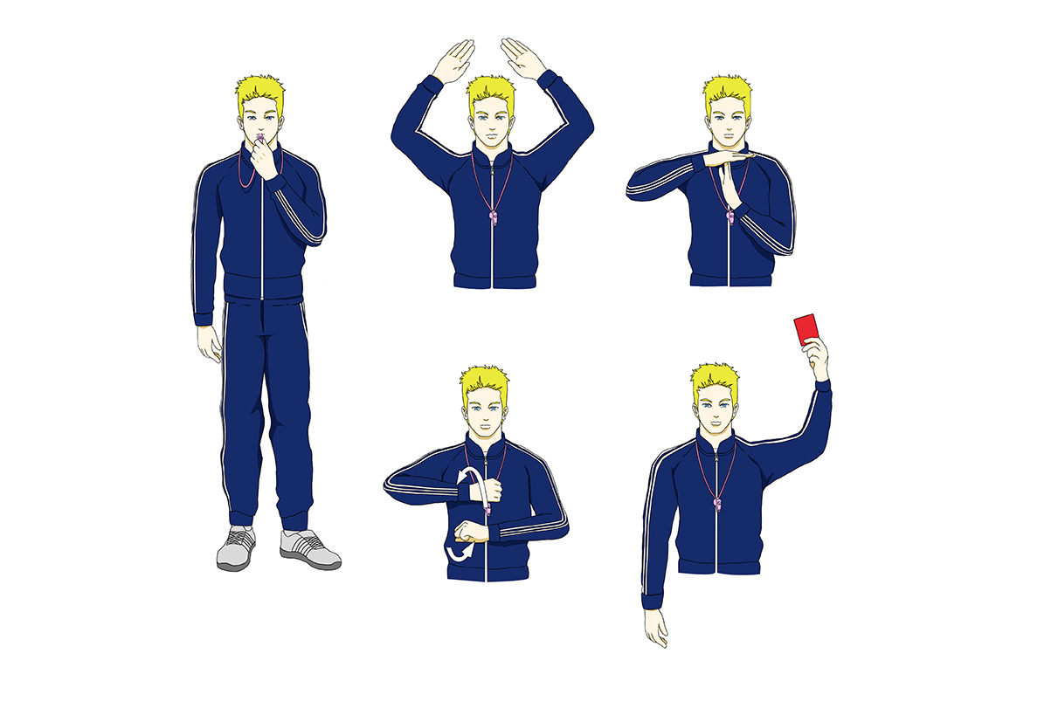

Pitch Size & Boundaries
Dragonball can be played indoors or outdoors on any size of pitch, e.g. a football pitch, netball court or badminton court.
If played indoors, the boundaries of play are the walls. If a Dragonball bounces off the wall it is still in play and there is no need to return a Dragonball to the centre when playing indoors.
If played outside, the boundaries are the pitch lines, or using your own markers if you choose to play on a smaller pitch. If a Dragonball goes out of play, the Dragonball must be returned to the centre of the pitch and it is then back in play.

Equipment
To play Dragonball you will need:
• An indoor or outdoor space
• 7 x Dragonballs
• Dragonball Bibs (1 bib per player, different coloured bibs per team)
• Dragonball Tail-Tags (1 tag per player attached to a waistband)
• 2 x Goals
• 1 x Whistle per referee
• 1 x Numbered Scoreboard.

